**SE1748 – SE161229 – Đỗ Thế Phi – Lab 1 SQL**

**Q.1:**

Retrieve products whose list price is higher than the average unit price Retrieve the product ID, name, and list price for each product where the list price is higher than the average unit price for all products that have been sold

**Q.2:**

Retrieve Products with a list price of 100 dollars or more that have been sold for less than 100 dollars Retrieve the product ID, name, and list price for each product where the list price is 100 dollars or more, and the product has been sold for less than 100 dollars.

**Q.3:**

Retrieve the cost, list price, and average selling price for each product Retrieve the product ID, name, cost, and list price for each product along with the average unit price for which that product has been sold.

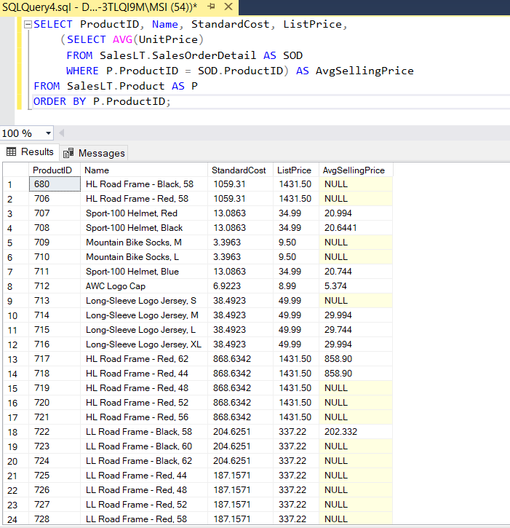

**Q.4:**

Retrieve products that have an average selling price that is lower than the cost Filter your previous query to include only products where the cost price is higher than the average selling price.

**Q.5:**

Retrieve customer information for all sales orders Retrieve the sales order ID, customer ID, first name, last name, and total due for all sales orders from the SalesLT.SalesOrderHeader table and the dbo.ufnGetCustomerInformation function.

**Q.6:**

Retrieve customer address information Retrieve the customer ID, first name, last name, address line 1 and city for all customers from the SalesLT.Address and SalesLT.CustomerAddress tables, and the dbo.ufnGetCustomerInformation function

